Cell Lab Specimens – (colored terms have Internet hyperlinks)
Bacteria – prokaryotes
Staphylococcus Aureus (cocci)
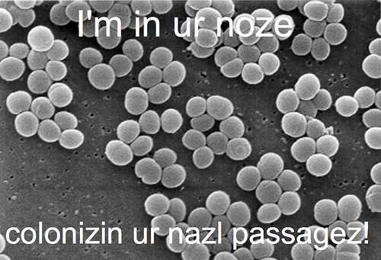
S. aureus can also cause skin conditions and other diseases.
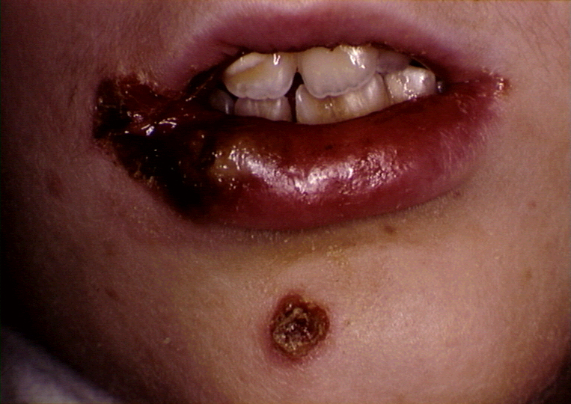
E. coli (bacilli) – lives in your intestines☺
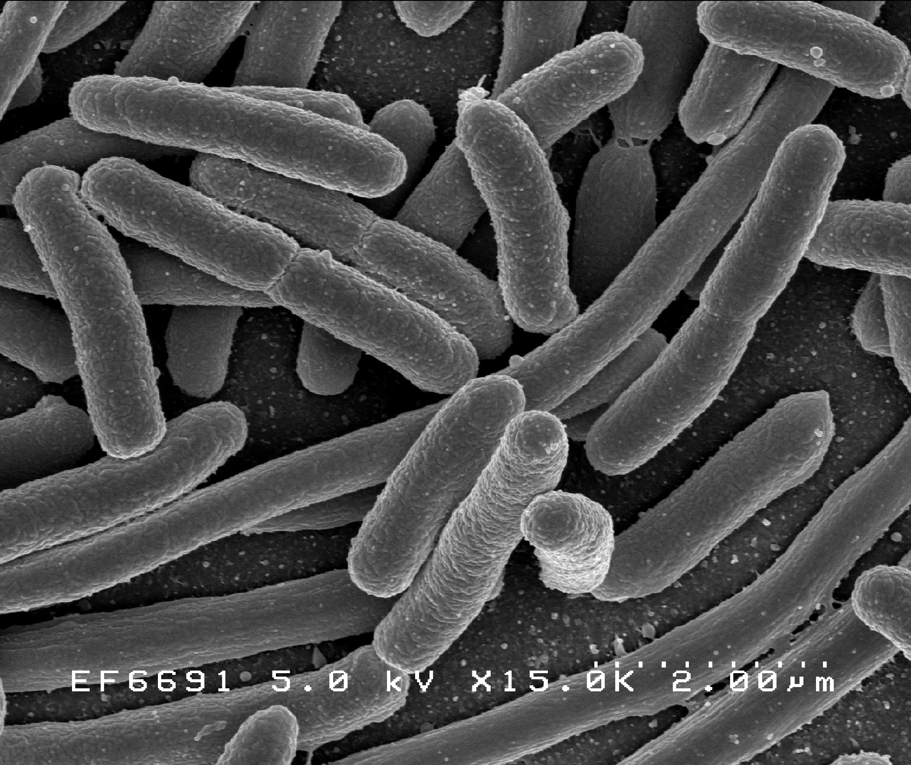

a type of spirilla that can cause syphilis
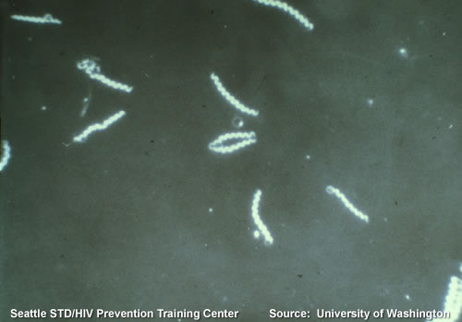
Cyanobacteria - photosynthetic bacteria
Gleocapsa – cells often appear in pairs or fours, surrounded by a gelatinous sheath.
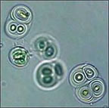

Merismopedia – cells stick together and form sheet-like structures.
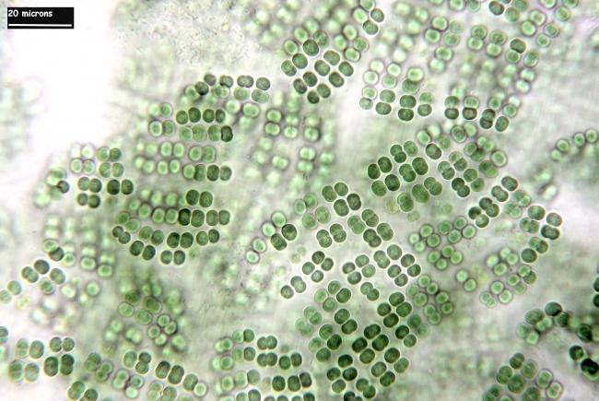

Oscillatoria – structure is referred to as filamentous (thread-like).
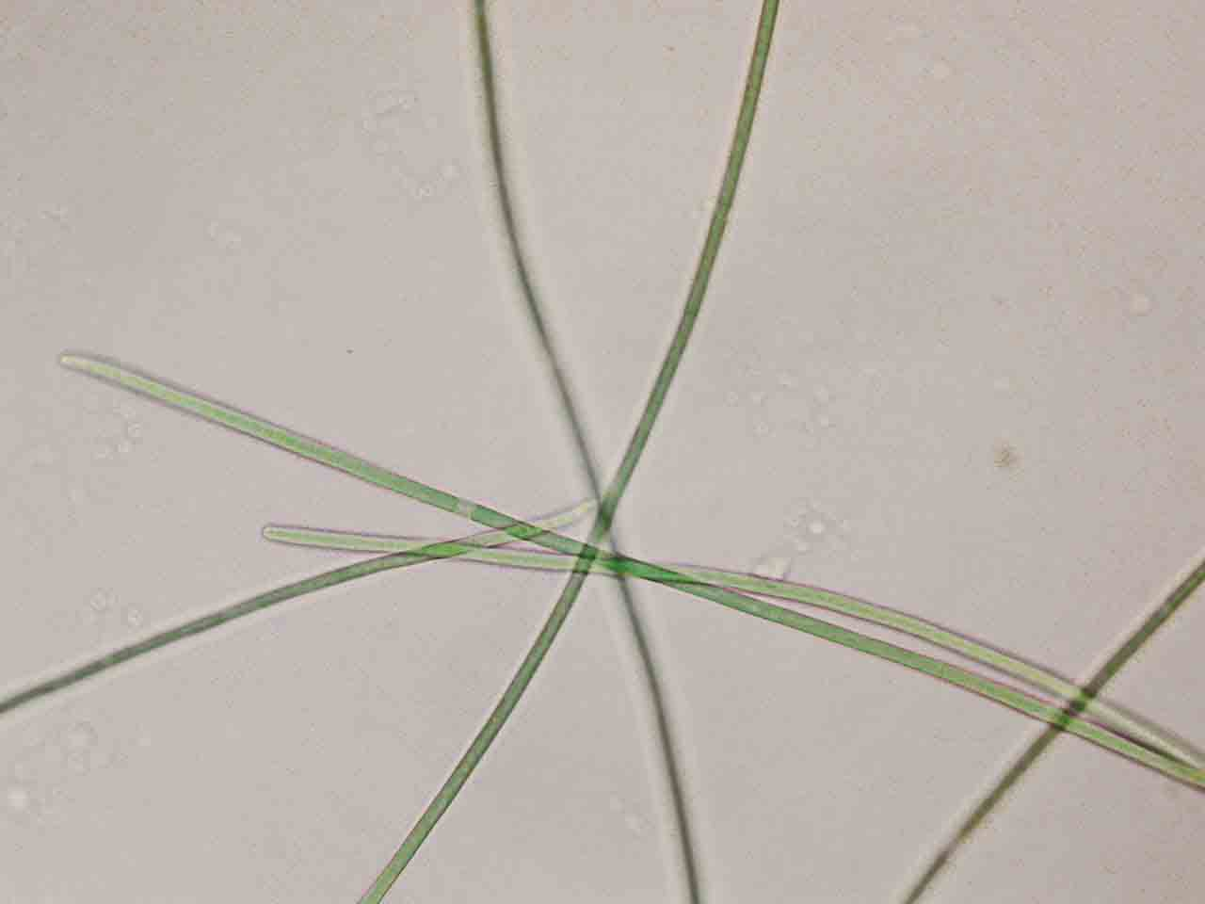
Oscillatoria closeup
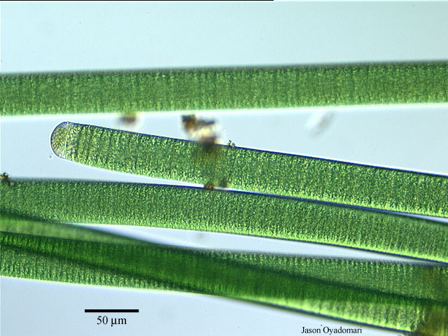

Kingdom Protista – unicellular and multicellular heterotrophic (protozoa) and/or photosynthetic (algae) eukaryotes
Spirogyra (algae) - Note the spiral-shaped chloroplast (green structure).
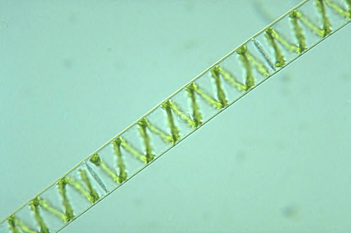

Paramecium (protozoa) – swims by means of cilia, fine hair-like structures surrounding the cell surface; and expels water using a contractile vacuole
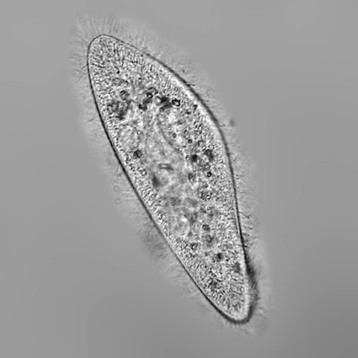
Amoeba (protozoa) – moves, and eats bacteria and other things, via pseudopodia (cytoplasmic extensions)
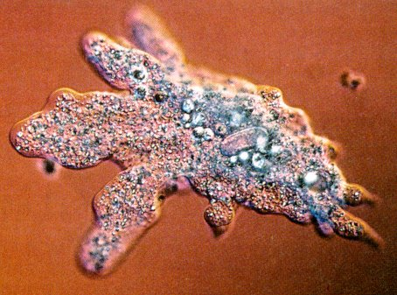

Euglena – may be heterotrophic or photosynthetic; moves by means of a flagellum (not visible here)
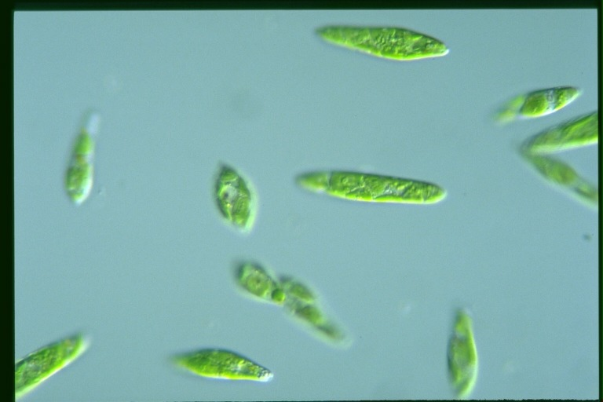
Kingdom Fungi – unicellular or multicellular, heterotrophic eukaryotes
Rhizopus – makes these zygospores during sexual reproduction
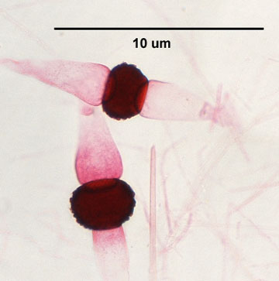

Rhizopus –These sporangia arise from the zygospores and produce spores which can give rise to new mold
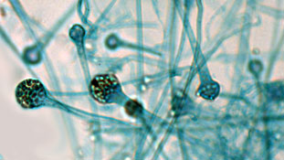
Kingdom Plantae – multicellular and photosynthetic eukaryotes
Elodea – cell walls are clearly visible, and note the chloroplasts (green oval structures)
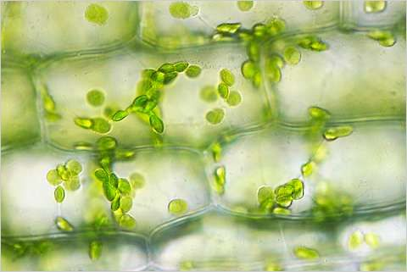

Potato Cells – make starch and store it in organelles called leucoplasts (purple/black structures)
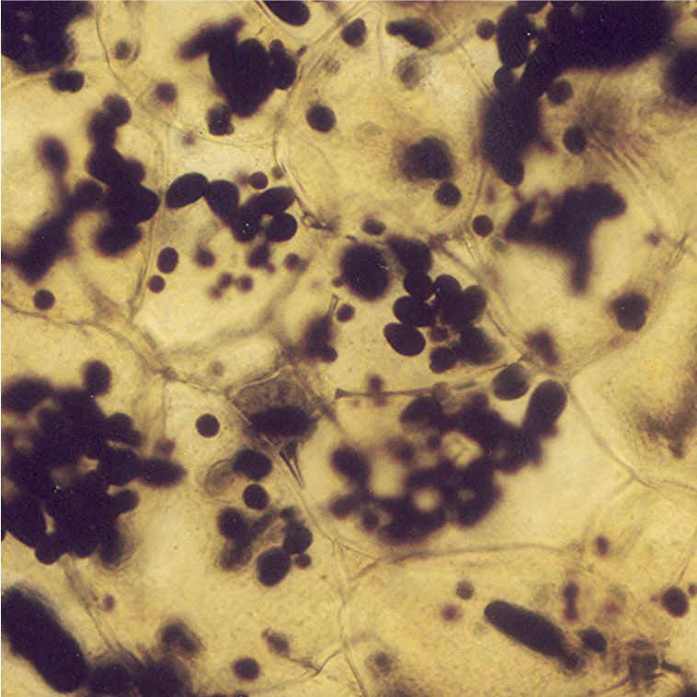
Kingdom Animalia – multicellular, heterotrophic eukaryotes
Cheek Cell


